Walk 31 Worcester Beacon
Last walked in July 2016

Description. A strenuous walk of 8 km (4.9 miles) as the crow flies, which should be carried out in clear weather.
Start. Car Park. Explorer Map 190. Grid 770469.
Direction from Whitecross Roundabout (Turn milometer to zero). Take the A4110 Canon Pyon (Three Elms road). After 1 mile at traffic lights TR. Continue on the A4103 towards Worcester and at 19.3 miles TR onto the A4219 Malvern/Cowleigh Road. Continue straight on to the end of the road, 21.4 miles, and TR, a few hundred yards on the left, just before a clock tower, is a pay and display car park [21.5m].

1. Car Park. At the end of the car park, the opposite end to the main entrance, proceed up a tarmaced track; the road is on your left. After about 100 yards the track splits, continue up hill and ignore the small track that goes downhill and to your left. Next, in front of you and to the right is a cliff face, just before that is a smaller track coming in from the right hand side, turn sharp right here and go up this track in the direction of ‘North Hill’, as a stone placard indicates. The track zigzags uphill to reach a junction where you TR and continue along Lady Howard De Walden Drive, which is a wide well kept track. Continue along this path for about half a kilometre as it goes around ‘North Hill’ to reach the top of a valley on your right.

2. Wooden Bench. At this point, by a wooden bench, TL and go up an undefined track between North and Table Hills - detour to either (or both) to admire the landscape unfolding to east and west. Descend, keeping Worcestershire Beacon (almost due south) in your sights. Around here there is a veritable profusion of paths – keeping to the ridge choose your own route to reach the trig point at the summit of Worcestershire Beacon, 1,394ft high.

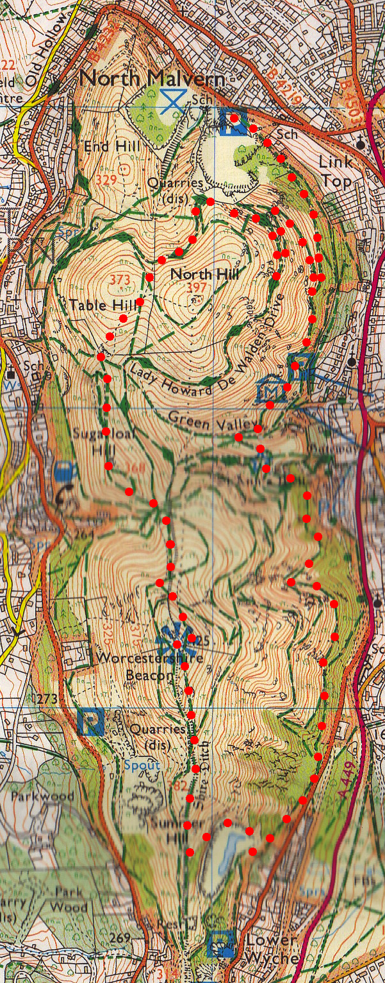
3. Worcester Beacon. Here is the usual triangulation column, also an excellent topography to assist you in identifying the features you can see. The name Beacon comes from the use of the hill as a signalling beacon during World War II the Beacon was used as a fire lookout point for air raids on Birmingham and Coventry. In recent years it has been used as a beacon for special occasions such as the millennium night of December 31, 1999 when a large fire was lit as part of a nationwide network of hill top beacons to celebrate the event. A cafe long stood just below the summit, until destroyed by fire - the terrace still remains. When you have drunk your fill of the views head off to the south, starting off down a tarmac/chip path on the eastern side, (left side) of the beacon. Continue down the tarmaced path and just past a concrete litter bin holder and bench you leave the path, which goes around the right hand side of the next hill top, to go straight ahead across a grassy area and onto a small dirt track that goes around the left hand side of the next hill top. Continue down the dirt track for a couple of hundred metres and turn sharp left down a small dirt track which soon meets up with a wire fence that surrounds a quarry. Continue down hill keeping the fence to your right and follow the track as it zigzags down to Earnslaw Quarry, passing an etched stone with ‘Quarry Walk to Goldmine’ written on it before you enter a clearing then the quarry itself, which was once an eyesore, now a beauty spot with a shallow pool. A track goes off to the left, opposite the quarry entrance, towards the main road; at the start of the track and on the left is a stone with ‘St Ann’s Well’ etched on it.
1

4. Quarry. Continue along this track, don't go onto the road but continue along the track ahead, this climbs a little. Near by is a wooden bench and a little further on is an etched concrete sign for ‘St Ann’s Well’. Contour around to St Ann's Well. The track does rise and fall slightly as you venture along to reach the well. At week-ends you can sample some pure Malvern water, in the room next to the cafe. When you reach St Ann’s well you follow the track that goes up and around to the left, after about a hundred yards you enter a picnic area. Carry on along the track ahead that goes slightly down hill, ignore the track on your left that goes uphill. After a short distance you reach the end of a tarmac road. Cross the road and climb a couple of rocky steps onto a track where you TR. Continue along this track that goes around the right hand side of the hill. Ignore any tracks on your right until you reach the cliff face with the placard for ‘North Hill’, here the track forks and you take the right fork downhill, the track will end up at the car park.
2

3
4

